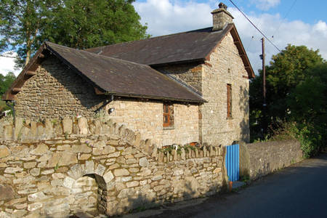

Mind The Gap Cofiwch y Bwlch

2020

June 2020

A4W Innovation CIC
Authored by: Mike & Sara

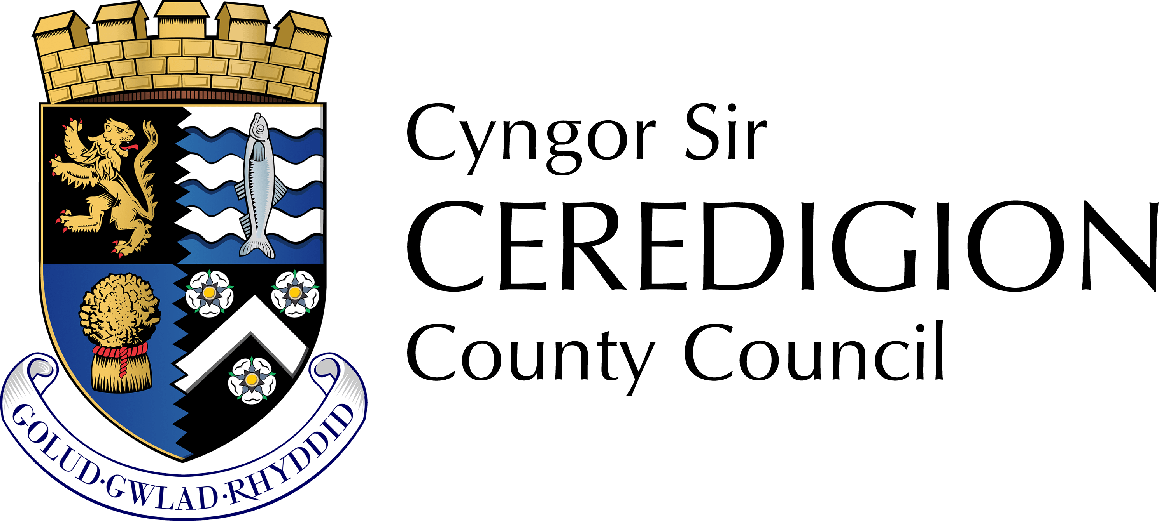
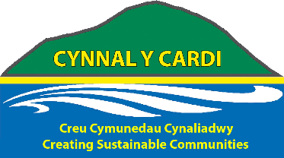

Mind The Gap / Cofiwch y Bwlch

Pilot Study: Bridging the intergenerational divide in rural Ceredigion communities.

Summary

Towards the end of 2020 A4W facilitated three induction and ideas generating workshops with 53 pupils age range from 9 years old to 16 years old from three schools in South West Wales. Three fact finding sessions with 3 managers, 2 deputy managers, 8 members of staff and 12 residents from three residential and day care centers in South West Ceredigion and contact with a number of community groups and organisations, to initiate the start of a potential; co-produced, intergenerational, community-based intervention that begins the process of putting residential care homes and day care services more into the heart of each community.

This practical fact finding intervention had the framework of a full day intergenerational ‘tea party’, hosted by each of the residential care home centres -Hafan y Waun, Aberystwyth; Bryntirion Tregaron and Hafan Deg Lampeter with a number of school pupils from each of the local schools: (Penglais, Bro Pedr, Ysgol Henry Richards) leading on the facilitating of the interactions and conversations, with residents, staff, family members and invited members of the local surrounding community.

Reminiscence artifacts, Creativity activities and tea party refreshments were the three main initial interventions employed for starting, holding and steering conversations between all the participants.

A4W ran training sessions with 53 pupils and 3 members of staff on the three school induction days.

Meetings with 14 centre staff members and 12 residents in prior discussions about the project.

A total number of 82 children, young people and adults were involved in consulting and co-producing the three intergenerational events

On each of the activity days collectively 54 pupils participated, 61 residents, 13 members of staff and 9 visitors from the community. A total of 137 participating.

Feedback comments can be viewed in appendix

Introduction

How might we, together, develop positive collaborative partnerships in rural Ceredigion towns to co-create a community development project framework that bridges the gap between elders, residential homes, young people attending local schools and the wider community, social groups, clubs and organisations?

How might we go about creating a framework which puts each residential centre into the heart of each local community?

And in the doing, what might the potential benefits be for all those individuals, groups and organisations?

“The core economy is made up of countless undervalued and priceless human and social assets that make it possible for society to flourish” Eleanor Ostrom

A4W Innovation CIC have been creating partnership opportunities, co-devising and facilitating creative community development interventions across the three Counties of West Wales since early 2010.

All our research, data collection, information gathering and anecdotal evidence have led us to believe that there is a vast reservoir of untapped individual and community assets, resources along with a desire for change, connectivity directly available within each and every community for the use of those communities across all the silos: Education, Community, Health & Wellbeing, Commerce, Residential settings.

Eleanor Ostrom – Nobel Prize for economics 2009 recipient talks about Co-production saying; “Co-production is a relationship where professionals and citizen’s share power to plan and deliver support together, recognizing that both partners have a vital contribution to make in order to improve the quality of life for people and communities.”

Inspired by the support from our established local partnerships, armed with a raft of National agency collected data, reports and information gathered from meeting up with professionals from these various agencies and organisations, as well as a recent airing of a television documentary that showed the differences made to young and old people alike through filming their interactions as school children visited a residential unit.
After discussions with our Cynnal y Cardi, Rural Communities Officer A4W put together an expression of interest and subsequently a full application to Cynnal y Cardi LEADER, to do an initial scoping exercise / creative intervention project that would begin building the platform for professionals and local citizens to come together and explore their potential relationships, to share power and begin to plan and deliver support systems together that would begin to put isolated, on the fringes of the community, residential centres back into the heart of each community.

“If it takes a whole village to raise a child, it also takes a whole village to support, look after and care for our elders”
A carer - Compassionate, Creative, Co-produced Community hub project participant

Project Rationale

The conceptual framework for Mind the Gap was largely informed from three major Community interventions projects facilitated by A4W.
- A creativity taster and asset mapping project community project. 2016 / 2017
- A community weekly social drop in activity project. 2017 / 2020
- Three Community Story Studio projects across two counties 2018 / 2019
Citizens were invited to share their opinions on relevant local issues, looking at past present and future

Creativity Taster and Asset Mapping Project Community Project

The Dewi Davies Foundation funded A4W to devise and facilitate a community asset mapping and creativity taster days in local village halls in rural Ceredigion.
‘On Your Doorstep’ 2016 – (15 community interventions, 150 participants) and ‘Down Your Road’ 2017 – (10 community interventions, 198 participants). With the five main responses to a face to face semi structured interview being:

People universally wanted:

- Somewhere to go.
- Something new to do.
- To meet new People.
- To make new friends.
- To feel safe in their communities.

Community weekly social drop in activity project.

The Cynnal Y Cardi three year funded pilot project 2017 -2020: A4W’s Cymunedau Caredig, Compassionate, Creative, Co-productive, Community Hubs: Initiating and creating eight, self-sustaining, self-governing, ongoing weekly social hubs. (Continuing independently after the weekly facilitation intervention period) with over a combined 240 regular group participants all sharing their views, opinions and feelings over the weeks around key themes for them pertaining to:

- Health & Wellbeing.
- Isolation and Loneliness.
- Family Breakdown.
- Community Breakdown.
- Education.
- Rural Poverty.
- Rural Employment.

Within which participants had lots and lots of weekly conversations and discussions about intergenerational connections; opportunities for intergenerational interactions; intergenerational project and event possibilities as well as opportunities and options for young people and their understanding of elders.

Story Studio.

Rural Futures funded ‘Inside Out Christmas Tree’ Llandysul Story Studio 2018 and Ceredigion PSB funded Cardigan / Penparc Story Studio 2019 created opportunities for local citizens to gather together and have conversations about a wide range of community issues sparked off through a wide range of creative interactive stimulus materials.

- People are ‘hungry’ to meet up and share knowledge of their communities.
- People of all ages, actively engaged and fully participating in memories of their community and ideas for development of community.
- Numerous personal and professional connections / re-connections made at the event resulted in other collaborative ventures and projects being initiated, business’s opening and a bust in numbers / animated conversations in the various community development / engagement forums.

Professional Partnership Potential Project Meetings

A4W have built up a wide range of partnerships of national and local organisations, agencies and support bodies who we work with in: Art, Health & Wellbeing, Community, Education, Heritage, Business, Tourism, Third Sector and local government. We keep in regular contact with key personnel and when researching a project idea or developing a project framework we work alongside the relevant organizations and staff. Meeting up with staff and asking about the magic moments and their headaches with their roles in the community gives great informed conversations about various approaches tried and requirement for further resources, offering an opportunity to explore ideas for interventions.

Conversations and Anecdotal Evidence.

Primarily, from these projects and meeting with staff we learnt of citizens fears, concerns, general conversational topics regarding their, family members, friends and community members experiences and interactions with their

- community.
- residential care centres
- schools.

Within each of these topic areas we were invited conversations covering a range of related anecdotal concerns, specifically:

Community: There was concern over breakdown of community services, the fear of changing communities, fear for their communities survival economically, the decline in community activities and events, lack of transportation, decline in local shops, School children bused out to bigger schools, parents commuting out to workplaces further away, rural poverty, sense of isolation and left behind.

Schools: general opinions stated, out of town, too large –too many children, early ages to young adults in same space, staff burnt out, class sizes too big, pupils not learning, too many pupils feeling failure, no room in curriculum, too many leaving without qualifications, an insistence on being academic and going to University, no life skills taught.

Residential care homes: On the outskirts of town, no easy access, transport, staff poorly paid, poorly treated and high turnover, too few staff, no monies for staff to do ‘extras’ just basic care

Around 2017 / 2018 Channel 4 aired a series that showed nursery school children visiting an elders day centre interacting with residents that obviously informed many of the conversations.

A4W had initiated their three year Cynnal Y Cardi funded pilot project: Compassionate, Creative, Co-produced, Community Hubs and witnessed first-hand the change in energy of all participants and the dynamics of the groups, at each school holiday times, as the weekly classes warmly welcomed children and grandchildren. (It was not unusual for us to have four generations participating in the sessions).

Project Application

The project aims to build links between older people who either live in care homes, extra care facilities or who live in their own home but have become isolated, with younger people, either through linking with schools or activity groups like scouts, young farmers or other youth groups.

The many benefits of engagement between old and young include improved understanding and more positive attitudes towards older people which can lead to less stereotyping and less anxiety about dementia and ageing. Some fairly new research also shows better job satisfaction for care workers through intergenerational working.

The project aims to begin to build relationships, ensure that any barriers, either practical or invisible, that hinder this multi-generational way of working across these residential, educational and community settings can be overcome in order for the initial connections to take place, the stories skills and knowledge that these older people have to begin being shared.

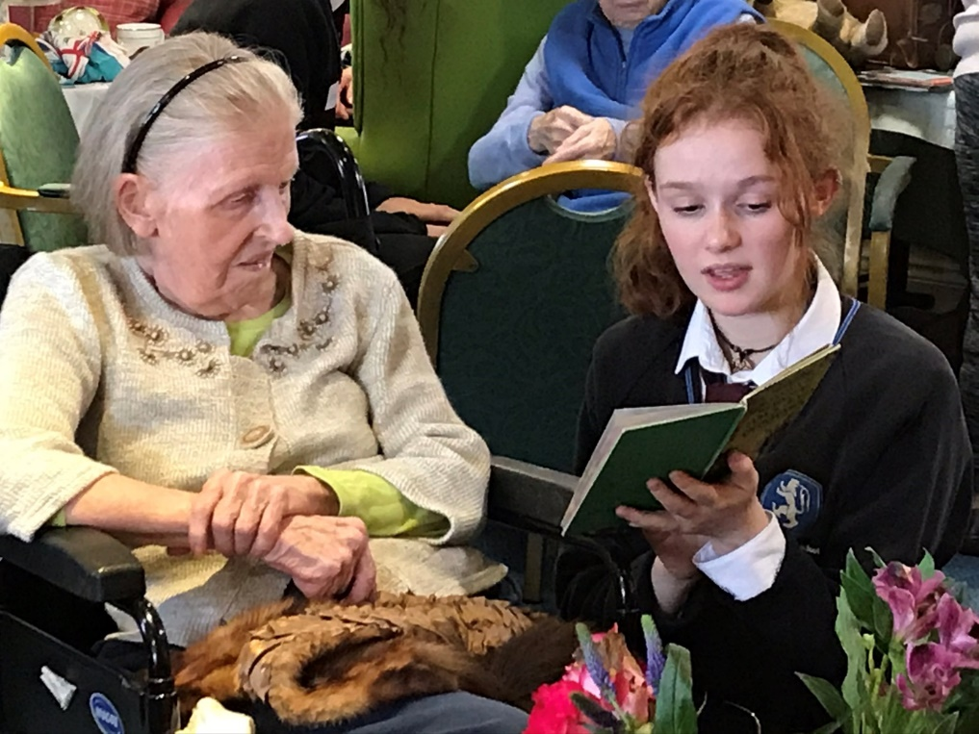

This will benefit the whole community:

- there is the potential for older people who feel isolated and have lost their sense of purpose will become more active and connected to the community, their knowledge and lived experience can be shared with younger generations.
- Younger people will have the opportunity to learn informally and in an interesting way from people with real lived experience.
- Awareness can be raised about any anxiety that comes from interacting together across different generations, through addressing it gently there is the potential to reduce that anxiety.
- Working together across the generations can encourage communities to become more connected and resilient, people will not only have the opportunity to engage with new relationships with residents but also to reconnect with people that they have lost contact with.
- Widening the levels of connection and engagement within a community has the potential to reduce levels of rural isolation and loneliness.
- Sharing stories and skills together within a community can strengthen the sense of belonging, sense of pride in where they live and foster sense of place, local distinctiveness.

The first stage will be scoping and feedback exercises that invite citizens of all ages, from three geographical area (Lampeter, Tregaron, Aberystwyth) to an event in the centre of each community. We will use the following process:

- Working in partnership with CAVO contact key individuals at local schools and universities, engaging with staff to promote the benefits to their pupils if they engage with the project.
- Facilitators to visit high schools to creatively engage the children in order for them to co-create and develop the project. This will give the children a deeper sense of ownership of the project and will encourge participation from the whole family.
- Working in Partnership with CAVO to contact key individuals at local care homes/facilities, personally inviting residents, their families and staff members along to the events. Also developing opportunities for volunteering links between care homes and schools for future intergenerational volunteering opportunities. The project will break down barriers of participation between the age groups, highlighting the support they can offer to each other.
- Facilitation of an all day event in each area, split into three sessions, am, pm and early evening in order to make the day as accessible as possible for the whole community. Transport will be provided for those who need it, and there will be a campaign to actively promote events by personally inviting community members.
- Follow up research sessions within the communities in a setting that will be familiar and comfortable for people, for example at the local Day Centres to develop stories and ask more indepth questions using skills such as ‘Most Significant Change’ and ‘Magic Moments’ to capture the voice of the community. The Most Significant Change (MSC) approach involves the collecting and sharing of community stories then develping them as a discussion of values with stakeholders and contributors so that learning around what is valued by the community can happen. Magic Moments looks at Developing Evidence Enriched Practice (DEEP) in health and social care, specifically with older people. Rather than a focus on what has gone wrong, or what is missing in a community, DEEP has been used to discover examples of kindness, compassion and heartwarming situations.
- Use the information gathered to put together a set of actions / project ideas that could be implemented in a stage 2 of Mind the Gap.
- Compile a final report which includes a number of case studies along with a set of actions that can be implemented in a future project(s).

Outcomes:
- To initiate intergenerational gatherings.
- To asset map individual skills, experiences and knowledge.
- Strengthening and widening existing rural community social networks
- Develop ‘social capital’ and greater appreciation of age and experience thorough intergenerational working
- To gather ideas for future intergenerational collaboration.
- Build a collaborative and integrated community based infrastructure
- To provide evidence of need for next step project
- To ensure that communities become an active part of the solution in addressing the needs and wants for that community now and into the future

Impacts:
- A celebration of lives lived, experiences, skills and knowledge attained.
- A bringing together of different generations.
- Bridge building between the generations.
- Mind the Gap / Cofiwch y Bwlch will provide a meaningful way for communities to influence service delivery
- Opportunity pro-active for engagement between agencies and community
- Building stronger community connections and understanding.

Fit with LDS:
1.4.1 To foster integration between different age demographics to support sustainable Welsh-speaking neighbourhoods and community cohesion. Phase 1 will be to:
Undertake a community engagement programme to stimulate interest and identify communities and/or networks.
Phase 2 will then be to:
Identify a community/network and provide support via a pilot project to facilitate integration.

1.4.2 To encourage greater engagement between different age groups to promote the transfer skills. One of the main aims of this project is to look at how skills and knowledge can be shared intergenerationally for the benefit of all.

3.1.1 To build the capacity and increase the confidence of individuals/groups to identify community development opportunities – by delivering an innovative community engagement exercise to stimulate community actions.
3.1.3 To improve communication and engagement within communities through innovative engagement.

Project Delivery

- Three project awareness raising, fact finding and ideas sessions in three schools.
- Three project awareness raising, fact finding and ideas sessions in three residential homes.
- Three intergenerational ‘tea party’ day events in three residential homes.
- Meetings with partner organisations.
- Phone and email contacts with third sector groups, community organisations.

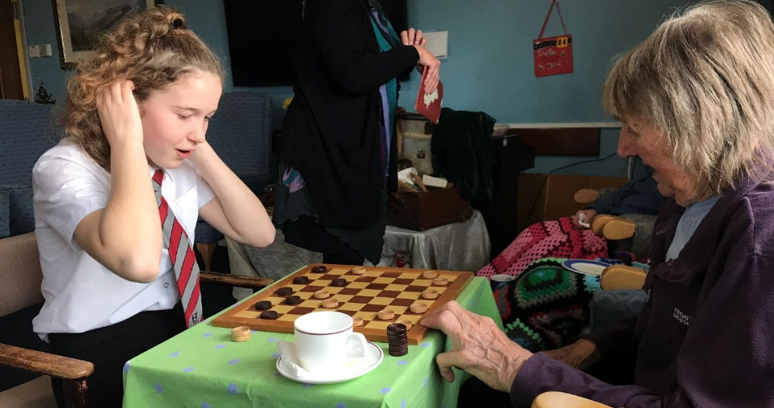

Project Delivery Framework
Schools: A4W Training module for children/ young people

Ysgol Penglais School, Aberystwyth; Intergenerational training and awareness session:
Delivered 10th October 2020 with 23 pupils.

Ysgol Bro Pedr, Lampeter; Intergenerational training and awareness session
Delivered 10th October 2020 to 12 pupils and one staff member.

Ysgol Henry Richard, Tregaron; Intergenerational training and awareness session:
Delivered 9th October 2020 to 18 pupils with two members of staff.

Initially envisaged a full days training for a wide age range of pupils from each of the schools. Planned a half a day interactive, participatory, creative introduction to the project with a range of activities and exercises to facilitate awareness and understanding of Elders needs and abilities as well as a fact finding and ideas generating session to share ownership of the event.

Residential Homes, Ideas Generation:
Hafan y Waun, Aberystwyth;
10th October 2020 with centre manager and activities officer and 3 members of staff. (1 male / 4 female)

Bryntirion, Tregaron;
30th September 2020 with 12 residents (2 male/ 10 female) and 5 staff – female.

Hafan Deg, Lampeter;
9th September 2020 with centre manager and 2 members of staff

Fact finding and ideas generating meetings, sharing ideas and ways forward with mainly staff alongside meetings with residents.

Tea Party events: Intergenerational Interventions
Hafan Waun residents, staff and pupils of Penglais School, Aberystwyth,
11th October 2020 with 14 pupil’s morning ‘elevensies tea party’. (5 males / 9 females)
18 pupils for the afternoon Tea Party. (5 males / 13 females) Residents involved not counted as there was a continuous flow of residents throughout the day approximately 45 – 50, 6 community visitors.

Bryntirion, Tregaron with pupils of Ysgol Henry Richard, Tregaron, 16th December 2020 with 10 pupils (1 male / 9 female) and 12 residents (female) 5 staff (female), 1 visitor (female)

Hafan Deg, Lampeter with pupils of Ysgol Bro Pedr, Lampeter, 14th October 2020
12 pupils morning and afternoon (3 male / 9 female), two staff members,
19 Hafan Deg residents (5 male / 14 female), three members of the dementia support group with coordinator, 5 Hafan Deg staff – (female), 4 visitors – two male, two females.)

Taking the idea of an afternoon tea party as suggested by several residents and members of staff and a number of school pupils as an overall theme and framework for an excuse to gather and meet up. We took along a range of activities as part and parcel of preparation for a party which people could identify with; Butter making using an old churn. Crafts activities such as card making, invitations, decorations, party food and drink preparation. A range of artifacts, memorabilia, games and creative activities through which participants could connect and hold conversations together.

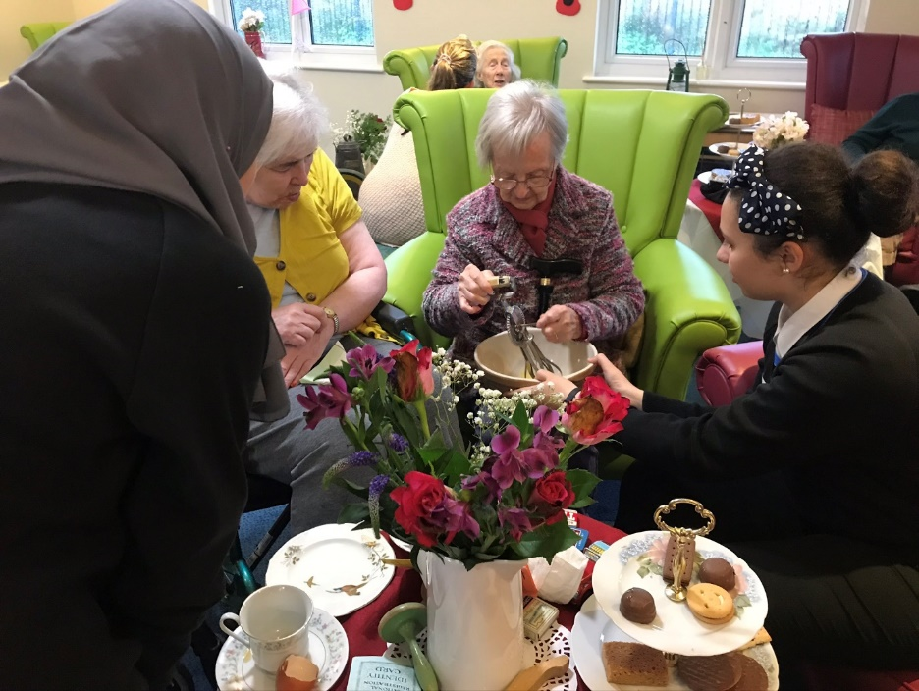

What worked
- Schools.
In a packed 45 minute training period in each school:
- Pupils really engaged and fully participated in induction sessions.
- Pupils took on an ‘ownership’ of project.
- Pupils came up with a variety of ideas and suggestions for event.
- Some pupils rehearsed entertainment pieces in own time, some pupils researched topics and some practiced art skills in own time as part of preparation for meeting up with Elders.
- Through the training the pupils embodied a much deeper understanding of working with Elders as people.

- Residential homes.
Staff:
In 30 minute meetings all staff were:
- Very interested and supportive of idea.
- Willingly offered up their knowledge, skills, thoughts and ideas.
- Really welcomed the initiative.
- Highlighted a strong desire to get greater community involvement.

Residents:
In a 3 hour reminiscence intervention session at one home:
- Residents (and staff) were thoroughly engaged.
- Welcomed team in
- Shared a great deal of memories, conversations and stories.
- Gave some ideas and suggestions for the event day, came up with the idea of a vintage tea party.
- The majority were engaged and keen to be part of the project.

- Intergenerational ‘tea party’ day events.
In a full day intergenerational ‘tea party’ event at all three venues:
- Participation and involvement was very high, surpassed all staff expectations.
- Lots of interaction, conversations, sharing and laughter between the generations.
- Very positive feedback from Elders, Young People, staff and visitors.
- Enjoyment in participating.
- Residents came out of their rooms to find out what all the buzz was about
- It worked very well having the events at the Day Centres because it was so accessible on the whole for staff to support residents to access the day’s events, mobile residents could pop in independently and enjoy the activities. Had the events been at the village halls as initially planned we would have reached just a small percentage of the elders from the homes and day centres though we would have reached more people from the community

- Partner organisations.
- Cementing working relationships.
- Initiating new partnerships.

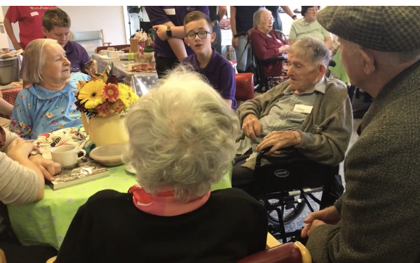

What did not work
- Schools.
- Initial difficulty getting into schools.
- Difficulty getting a substantial time slot due to busy schedules.
- Some confusion as some members of staff had fixed ideas after seeing a recent television programme demonstrating one method of intergenerational working, curriculum being very structured there was a bit of confusion about delivering a flexible co-production framework, encouraging and supporting things to evolve led by pupils and residents but this is something that we can work with
- more time needed building the relationship with schools before running project, this was a very useful learning point for us, as in the past schools have really wanted us to work with their pupils so we weren’t anticipating any difficulty with that engagement.

- Residential homes.
- Lack of space in venues to do the larger scale work (i.e., Historical timeline.)
- A large percentage of residents so far along a dementia journey, information and ideas gathering not viable.
- Intergenerational ‘tea party’ day events.
- space a bit of an issue with the numbers of people wanting to engage and ensuring there were no trip hazards, ensuring space for mobility frames, wheelchairs etc.
- Slight challenges negotiating changing the layout of tables and chairs to create a friendly sociable café style feel to the events

- Final Tea party, film sharing event at three residential centres
- Three films were created in partnership with a UWSTD Third year film and media student using the photographs and film clips from the Tea Party events, the plan was to invite the pupils back to the centres and share the films with all involved however in the early days of our awareness of Covid 19 we were having concerns as to whether intergenerational working was still advisable, within a short time the Care Homes were closed for the safety of the residents. So the links to the films were forwarded to the care homes with the suggestion that perhaps a tea party event could be held. However, things were very uncertain in early March as we had no idea how long the issue would continue or how serious COVID would turn out to be

- Partner organisations.
- More time needed to build relationships than initially anticipated.

- Third sector groups, community organisations.
- Despite numerous approaches, incredibly difficult to get responses, engagement from groups and organisations.
- A lot longer lead in time needed to build connections and relationships, and find slots in each organisations and groups busy timetables.

Conclusions

Although the project was a lot smaller in scale than originally envisaged. (located at each of the residential centres and not in each regions community centre – this was requested by the residential homes); and although there were difficulties in getting into the schools. (A4W are used to schools welcoming us in straight away); and a real struggle to get third sector organisations, clubs and societies to engage. The pilot project was a great success with Elders, School pupils, residential centre staff, School staff, A4W staff and family members overwhelmingly actively participating, engaging and gaining a great deal from having done so.

There appears to be a real desire for far more intergenerational connections and contact. There are real changes in perceptions, understanding, awareness and pre-conceived ideas on all sides of the generational and professional divides, evident by the feedback in the appendix.

There is a great untapped opportunity to co-produce a series of community interventions with these participants and other organisations that would not only be welcome from all, but also of incredible value, life enhancing and enriching experience for all involved rippling out to the wider community.

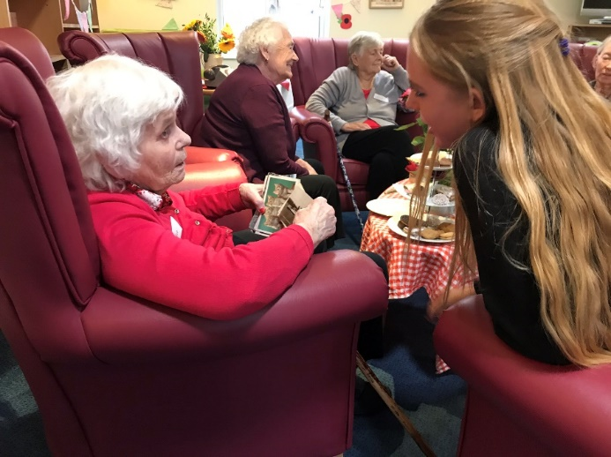
Recommendations

Residential Centres
One of the recommendations from residential centre staff and managers is that there is so much more they would like to do with the residents, however they do not have capacity. (Mainly due to number of staff required to support elders with mobility issues, frail and vulnerable). Also, levels of staffing generally are low and financial issues regarding cost of transport, entrance prices, refreshments are more often than not prohibitive. Such things are regarded as non-essential, therefore no budget.

Centre staff and Managers would warmly welcome more able bodied community members to participate in both indoor and outdoor activities. More integration with wider community would benefit the centres.

All three centres would benefit from community volunteers with regards to helping residents access the outdoor spaces, volunteers/ community interest groups to help with taking care of the outdoor spaces. We discussed a number of ideas and there is of course potential for this to happen with the schools. Bro Pedr would like outdoor learning space – could there be an opportunity for reciprocal working to create this at Hafan Deg?

A safe framework to enable more community interaction, with volunteers bringing pets in, mainly dogs as many of the residents particularly in Hafan Deg are from a farming background and miss interaction with animals. Insurance and training of the dogs, some kind of certification so that management felt confident of safety.
We also discussed keeping chickens and the therapeutic benefits for residents, however the issue would be capacity again so a community volunteer run project would be the idea option to ensure that it didn’t bring additional pressure on the staff.

Schools
Teachers were really keen to have pupils more connected with elders as it had proved to be an invaluable interactive experience providing learning opportunities for all.

A call for more projects that they can get involved with in their local residential centres, especially now with changes in the Welsh curriculum around wellbeing, would be seen of great benefit to school and pupils.

Pupils
A real strong desire to do more of these intergenerational activities that are co-produced and evolve rather than the traditional prescribed way of classroom working.

A real interest in sharing skills and knowledge in conversations and activities as well as creating entertainment pieces to show their skills and interests.

A4W
That a longer and more gradual time frame be allowed to build up all the various relationships and networks across the wider community be developed to better enable the involvement of the various community groups and organisations.

That an annual co-produced calendar of seasonal events is initiated from the start for a three year period with each residential centre, school and local groups to provide an initial framework for participation and involvement.

That a budget is drawn up that will cover the cost of members of staff from the residential centres, the schools and community groups to attend project development meetings / intergenerational event days.

Appendix 1
Bryntirion Residential Centre and Ysgol Henry Richard intervention day feedback.

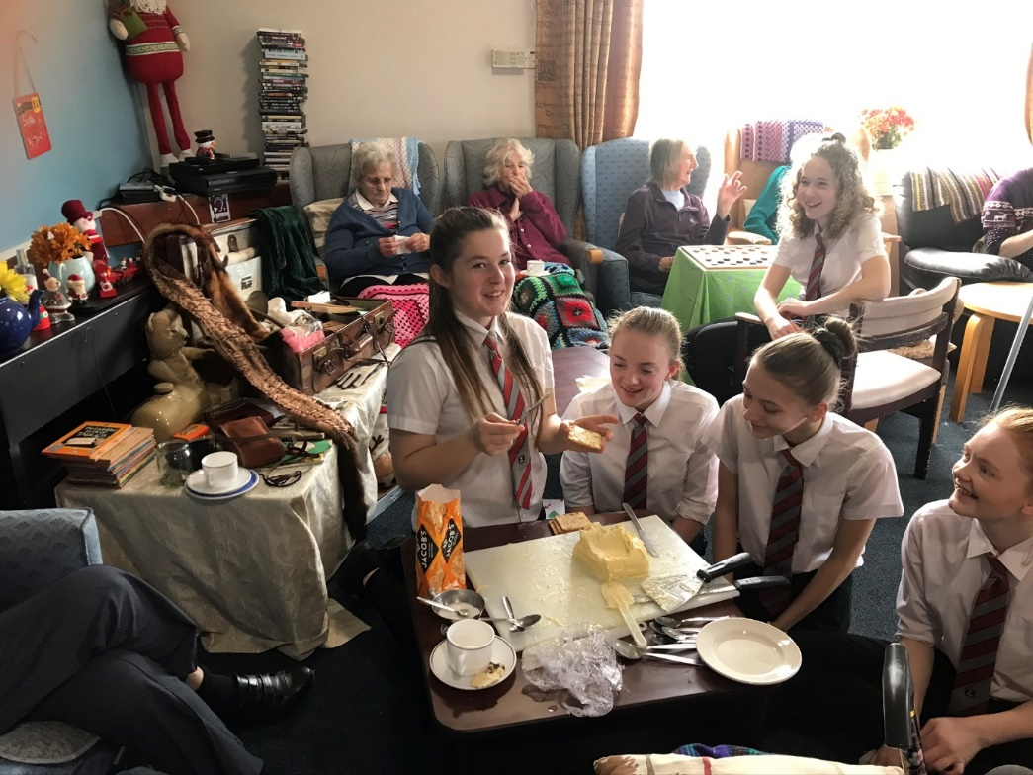
Pupils
What did you think and feel about this today?
Megan: “I enjoyed it, was nervous at first, what will I talk about. Played draughts”.
Best Bit?
“Playing draughts and talking about how to play draughts, about Christmas, where we lived and what we had come to do.”
What will you take home from today?
“About making butter and how hard it is”.

What did you think and feel about this today?
Taylor “9/10 nervous about being here, enjoyed helping and the whisking”
Best Bit?
“Being out of school, you’re in charge of your own education; learn what you need to learn.”
What will you take home from today?
2Helping people”

What did you think and feel about this today?
Gemma “10/10 It’s been fun! No boring lessons! Coming here, I was nervous at first, coming to a place I did not know, had not been to before, (how would it be?). Then they all just went with it”.
Best Bit?
“Everything”
What will you take home from today?
“Talk with people more. In giving something the response is happiness”

What did you think and feel about this today?
Teleri “10/10 meeting people, a bit nervous at first, did not really know what to expect, talked to people, used the artifacts, used the whisk, did the activities.”
Best Bit?
“Making the butter, a totally new experience”
What will you take home from today?
“Memory of butter making”

What did you think and feel about this today?
Ellen “10/10 because it was fun doing new things, especially butter making. Did not really know what to expect.”
“Was it easier coming as a group? “Yes”
“Would you have come on your own?”- pause “Maybe”
“Would you have come on your own now you have been here?” “Yes”
Best Bit?
”Making the butter, different from anything I have ever done before”
What will you take home from today?
“The experiences of the whole day”

What did you think and feel about this today?
Megan”9/10 Good; at the start did not know really what to expect. Never expected I would sit here and make butter.”
Best Bit?
“Making the trifles, meringues and using chocolate sprinkles”
What will you take home from today?
“Good feeling of making food and making butter from start.”

What did you think and feel about this today?
Lisa “8/10 Just did not know what to expect really, just came in and started talking, picked up a jar and started conversations, did not know what I was going to ask, it just happened”
Best Bit?
“making the butter”
What will you take home from today?
“How to communicate more with Elders”
Staff - Teachers and Volunteers.
Miss
What did you think and feel about this today?
“Fantastic! A great experience! Observed them socialize with confidence and use their initiative.”
Best Bit?
“For me personally, it was the pupil’s confidence and initiative use”.
What will you take home from today?
“A deeper understanding and awareness of pupil’s maturity”

Miss
What did you think and feel about this today?
“You could tell the nervousness of them coming in first thing but how they very quickly opened up, showed confidence and quickly started communicating and going with the responses.”
Best Bit?
“The butter making jar! An excited team effort”
What will you take home from today?
“The pupil’s confidence level, rose to the occasion. Really hope the funding goes through, so the pupils can get another opportunity to do it again”

Marie
What did you think and feel about this today?
“Great, really good. An idea that has been around for a long time, took a lot to get it to happen. But doing what we all hoped it would, great interaction from both the Elders and the School Pupils.
Best Bit?
“M. telling you that she knows what you’re really saying – she should p*** of”
What will you take home from today?
“The power pants conversation, so funny”

Susan A4W Volunteer
What did you think and feel about this today?
A new experience and was really looking forward to it. A real delight to see all the young people just strike up conversations, helping themselves to the artifacts out of the reminiscence case, props if you like, to help have a conversation, asking the Elders if they could tell them what it was. In those exchanges, witnessing the confidence of all grew and grew as the noise levels in the room grew and grew. Very soon everyone was engaged in exciting conversations.
Best Bit?
Seeing the pupil’s confidence grew – you could feel it!
What will you take home from today?
Hope to get to do more stuff like this. It’s so important! All ages can be lonely, we all make an effort, use a prop, start a conversation. Bring a few things together and memories will flow forth. Youngsters can do something for residents. The making Christmas cards and handing them out made people feel special.

Cai A4W Volunteer
What did you think and feel about this today?
Great, Lovely day! Really nice to see everyone happy and trying new things. Nice and Warm inside and great idea to take things into centres and have people come in to do things with residents.
Best Bit?
Tasting the home made butter on the cracker! Only you two would have thought of that as part of the creative activities”
What will you take home from today?
“The feeling that I would like to do much more of this kind of thing. Get into homes and have conversations with people”

Dee – Staff – (Popping in and out busy doing work load).
I really liked:
Meryl with the pants
Butter Making
Cake making
Thumb Piano, when participants played it, everyone listened, everyone wanted a go.

Clare – Staff – (Popping in and out busy doing work load).
What did you think and feel about today?

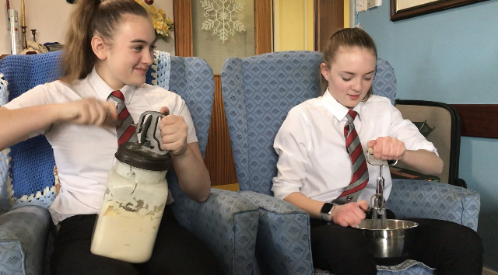

“It was really, really good, everyone has thoroughly enjoyed! Everyone talking, all enjoyed all the interactions and sharing experiences, they will be talking about this for next few weeks”.
Best Bit?
“Seeing everyone smile and happy. It is hard to get them all to do something and enjoy it. So many different activities, something for everyone”.
What will you take home from today?
Make some more butter! They used to make it that way, find things that they used to know and do.

Residents.
“It’s been a really good day thank you”.
“Really lovely to watch the young people making butter like we used to when I was little, can’t do it now, have no strength in my arms anymore.”
“I really enjoyed talking with the young people”
“All the old things, IO have really enjoyed seeing them, holding them and remembering stories. It’s really nice to see all the old things again at my age”
“Very good afternoon, thank you, went very quickly. Bringing back all those memories. Would not like to go back to the old days though too hard work”
“Loved helping make the jellies!”
“I really enjoyed playing the games, a real nice change.”
“Just watching, love watching these days.”

Ideas and suggestions for next time?
Making and sharing of food.
More activities like dry felting.
Things that can be done on laps.
More sets of board games so more people can play at same time.
More old games like Whist and Beetle drive.
Children’s clapping songs, skipping songs, cats cradle, elastics, skipping ropes and yoyo’s
Old Spinning tops.

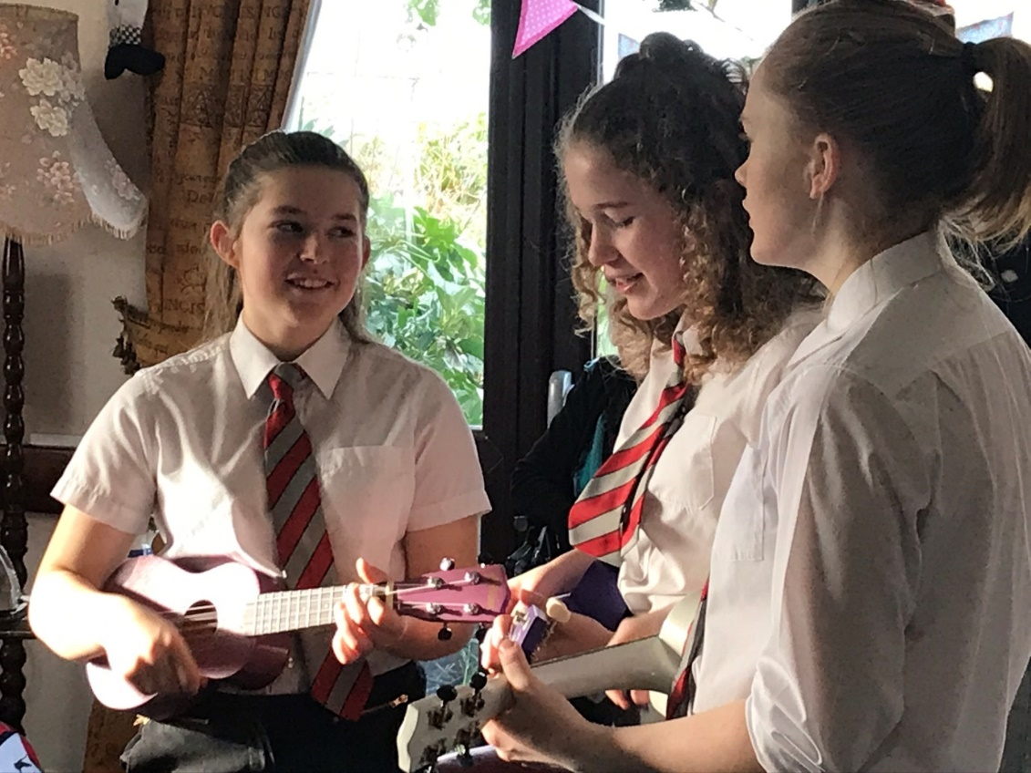

Appendix 2
Hafan y Waun Residential Centre and Ysgol Penglais intervention day feedback.
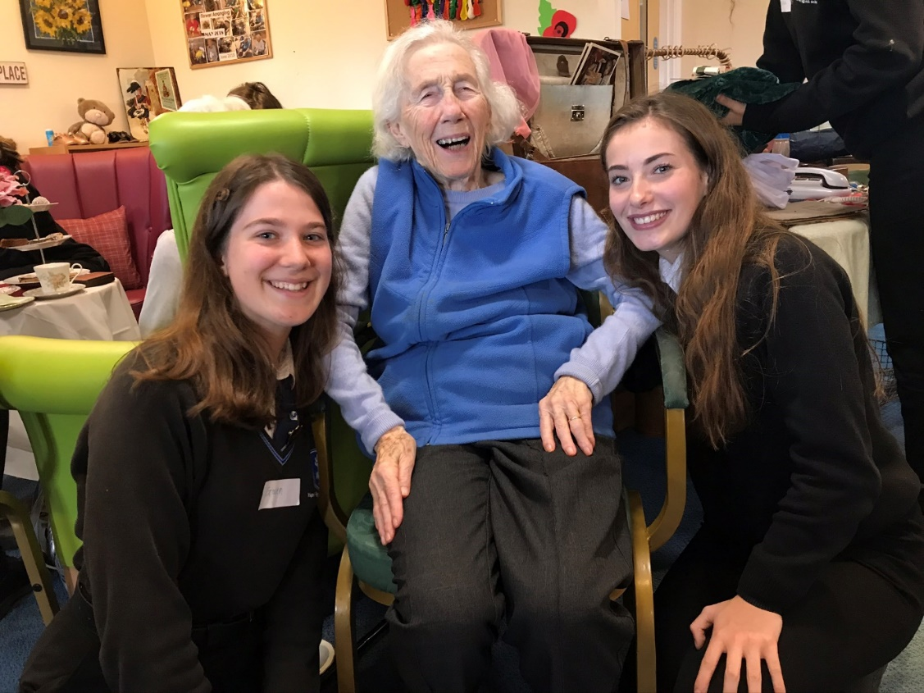
Participants
Emma (daughter of resident) “The more cross generational projects we can have the better.
Thelma: “I’ve really loved it!”
Olwen (family member): “The girls have been really lovely- I have really enjoyed myself, I like the old and the new things I think they were lovely, must sort out my button box and bring them along”
Daughter and husband came along to take her mother out for lunch: “We have, all three of us, shared the family memory photo album with all her friends and some students. It has been wonderful!”

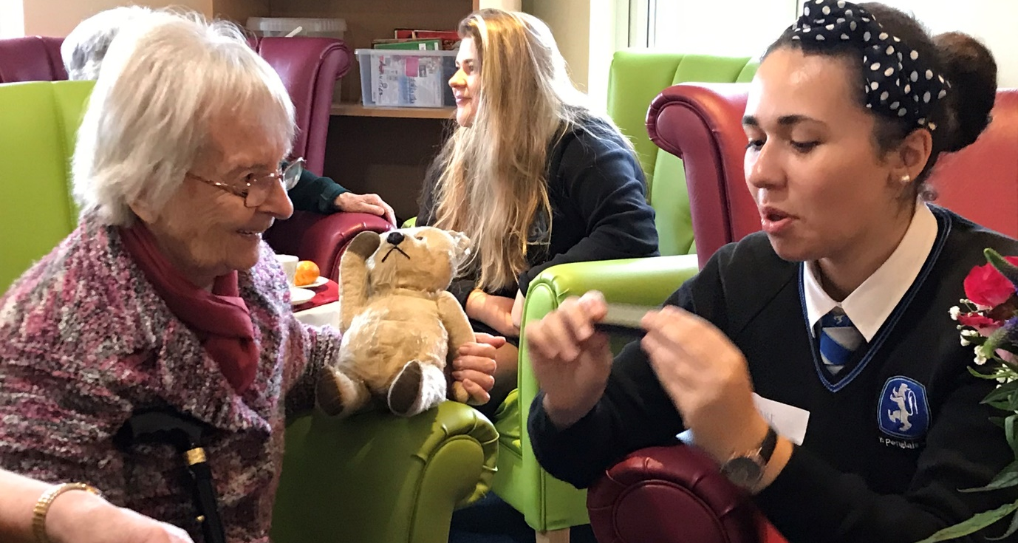

Staff
Clive: “I’ve never seen so much interaction”
Sally: “What a great friendly day and should definitely happen more often”
Social Worker: “How really lovely it was for there to be noise and so many people enjoying themselves.”
Linda: Feeling quite emotional about the day, so much; especially Bob as he never comes out of his room. We learnt today that he probably used to play the mouth organ. His wife comes in every week and he does not recognize her. She will be really pleased to see the photos of him participating. I am just so pleased he has joined in.”

Member of staff (As Linda said Bob never leaves his room. He keeps himself to himself, stays in bed much of the time, do not know much about him. He heard something was happening in the day centre and came to have a look. He joined in. Left at lunch time and even though it was the upper wings residents turn in the afternoon, Bob took it upon himself to return and join us for the afternoon session).
Linda (continued). “Residents don’t stay very long, they come in, stay about 10mins and go again. A few might come back again but they do not stay like this. It has been a real gift of a day, having help to be with the residents. Staff are great, but they have very little time to stand back and be with them like we can. But this has been a real help, a boost, to me; what could be possible.”

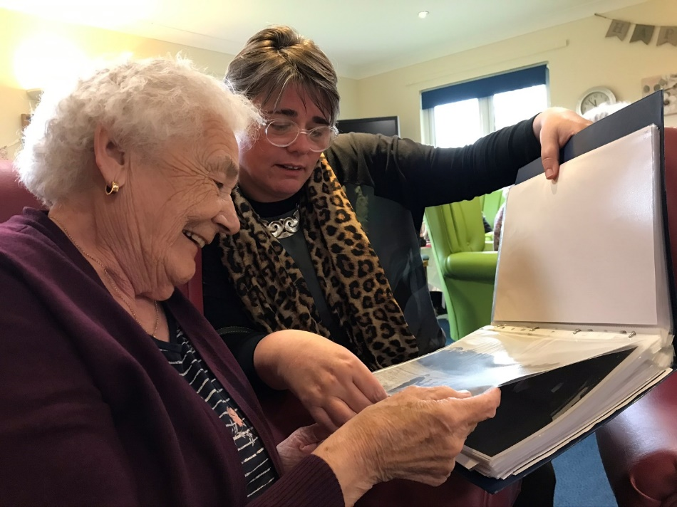

Hannah A4W Vol: It was truly fabulous on Friday!
I was very impressed by the young people that came along, their ability to dive in and connect with the residents, their maturity in talking with us and what barriers they were facing with their communication. They showed such grace and maturity. It would be fab to feed this back to the school.

Whilst I was impressed by the level of involvement from the school I think the afternoon session was oversubscribed and possibly created a barrier for some of the residents in coming into an environment which could have been over stimulating for them. There was one gentleman in particular that took a considerable amount of time before he was able to come into the room. That said, he did and that was such an achievement! But something to consider for the future.
The volume of people also I felt put a risk for residents moving around the space. Vern, who came back for a walk around in the afternoon but wasn't able to stay with us, made me realise we need to be aware of this and also with artefacts gathering next to chairs, on the floor etc. Just from a risk assessment point of view.

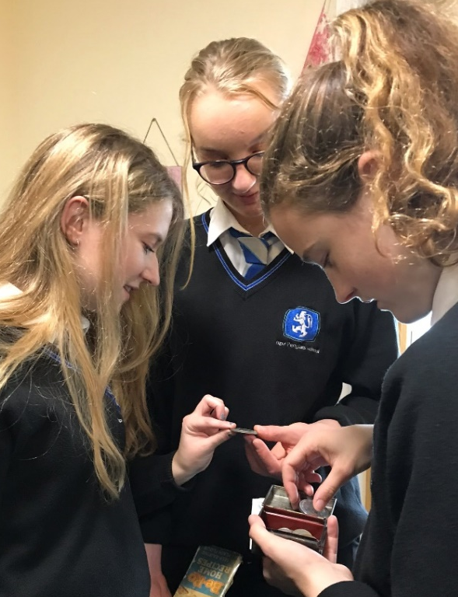
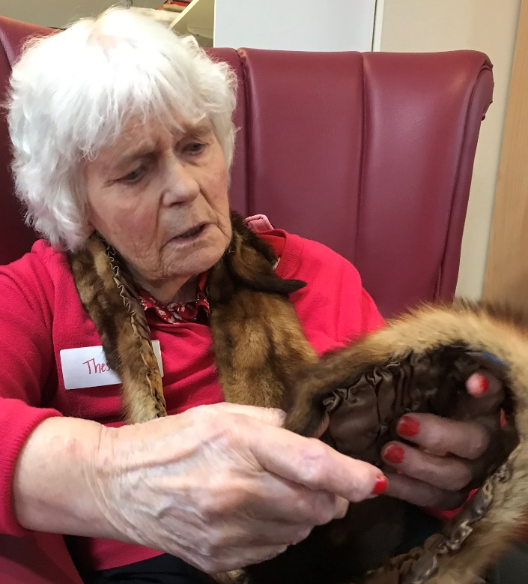

Residents who were further along on their Dementia journey seemed to really connect when being read to, and a great activity to suggest to the young people if they are finding barriers to connecting with some of these residents. I could see that all/any efforts being made were appreciated and just the fact that we were present and listening was beneficial.

For me personally the day generated a wonderful warm sense of connectedness. The staff were amazing, especially Linda. It was supposed to be her day off but due to staff levels she had to come in but she told me that she couldn’t have thought of a better way to spend her day off. The day definitely had a positive impact on the staff there.

So looking forward to Monday.

School Pupils
The morning and afternoon sessions were so full on that we did not get an opportunity to gather feedback from the young people.
Ronan: “It’s been really great, I’ve really enjoyed myself, I thought it was really nice how the person I was working with really lit up and really connected with the pictures of the families”
Katie: “I have loved today, many thanks to everyone involved! I talked with Phyllis, I am 17 so at this point my career choices are quite important; (exciting yet scary and confusing) Phyllis shared a lot of wisdom and it was very special to me personally.”
Anonymous School pupil: “The staff were so supportive and lovely to all residents; I have honestly had the best experience to date”

Next Time
Anonymous school pupil: “I would love to follow up with a book making / story writing / painting and drawing competition inspired by resident’s stories”

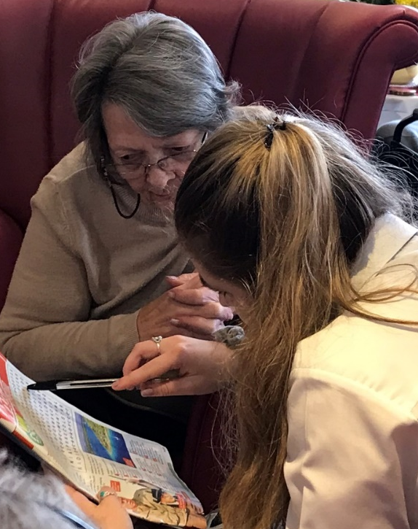
Appendix 3
Hafan Deg Residential Centre and Ysgol Bro Pedr intervention day feedback.

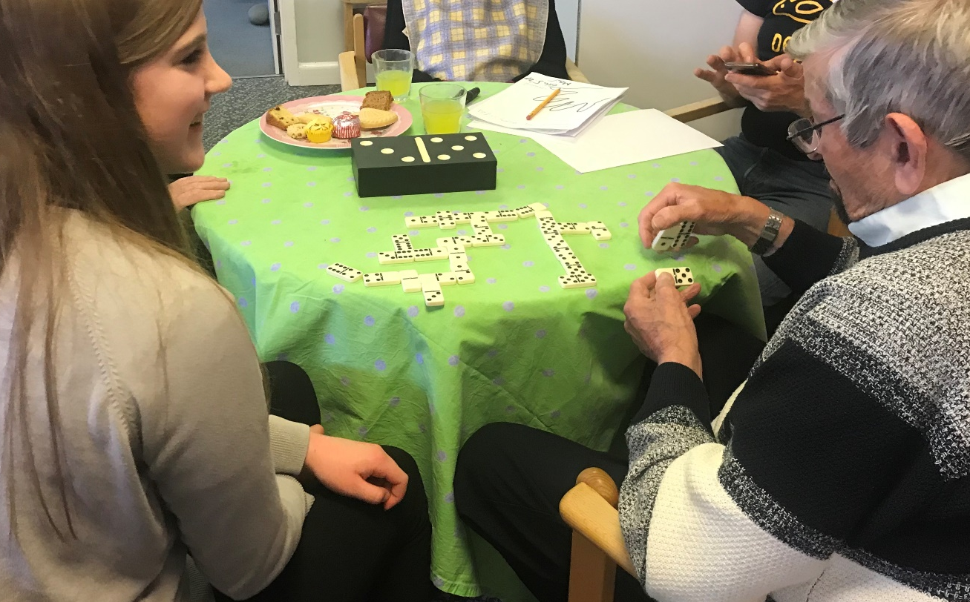
Participants
LJly: “I really really loved it, the children were the highlight. I made a giraffe with a little girl” (This now takes pride of place in her china cabinet)
BP: “I enjoyed the company, it was so nice to see a change of face”
RW: “I’m too tired to talk but it was good”
VE: “What a lovely change”
Lottie: “Seeing everyone smile and laughing.”

Staff
Miss: “Really good, nice to see little ones interacting with elders and everyone really enjoying.”
BB: “Nice for them and us to have time out of school together in the community.”

Miss: “Better this afternoon with the activities, having tasks much better.”
BB: “Learning about the character’s stories”

Eve: Really interesting with younger children, so unself-conscious with physical affection – sitting on knees. A real merit in having younger ones doing joint Decoupage model.
BB: Calon Lan singing and the sitting next to an elder and drawing something from their conversation.

Katie: Lovely day, how different every session is – same principle but very different sessions.
BB: Singing! Liked the music.

Staff member: “The day centre was buzzing today, its lovely to feel the atmosphere”
Staff member: “I haven’t seen the residents so involved in something”

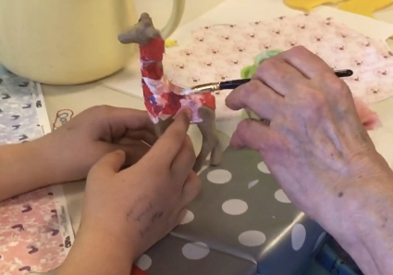
Hannah A4W Vol:
I asked the teacher for her input on activities that she felt would suit the session; the young people working with the residents. Her response was that the pupils she had brought were chosen as they were all fantastic at art and that maybe the residents would enjoy watching them create, and maybe then could work together with adding colour etc. with the final piece being taken away by the residents as a reminder of the day. The 2 young girls, Lottie and Lauren worked well with this and incorporated the names of the ladies into their drawings. Lilly also worked well in this way with Danny, drawing a fab picture of a truck for him. Once Wendy saw this interaction with the art activities I sensed her spirits lift and she seemed more at ease to move around the room. We also chatted about bringing more children from the junior school and how it would be lovely for them to bring along their Welsh reading books to read to the residents. A beneficial activity for all she felt. There are also plenty of Welsh songs that could be sung with the children which I'm sure would be known by the residents too.

It was lovely to see the knitting coming out and the decoupage. As there were a few from a farming back ground and even a woollen mill worker in Aberystwyth I thought peg loom weaving may be a nice activity, using either raw fleece or wool. The work isn't quite as fine as knitting, quite forgiving and grows very fast so within a session with everyone having a turn we could realistically create a seat pad. I still have a few peg looms and would be happy to bring them along and organise some fleece.

Centre Manager: “loved the whole day, everyone has come out buzzing, Joyce, never really communicates, she’s a people watcher, she loved it! This is a very local rural community residential homes, no locked doors, it is ‘their’ home, we try not to have an over regimented approach to tasks. People come and visit a family member, they meet other residents that they know from local area, they re-connect and carry on coming and visiting friends when their family member passes on”.
“Magic moment for me was Lil holding her decoupage Giraffe that they made together.”

Crossroads Dementia Sub Group.
Carol: “Our group normally is separate to the residential centre, it was immensely enjoyable, had everyone interacting, especially those who never get involved. It was invaluable having the youngsters multi-intergenerational, because they so love to see young people. Our dementia clients love the interaction with young people. Getting Gordon out here with you was initially very difficult. People can be real clinging to familiarity and routines that they know. I kept saying come out, everyone’s really friendly. A great opportunity for him and the others to get involved.”

Pupils
Keely: “Really good because we got to spend time with a lot of people”.
Best Bit: “The food”

Darcey: “Good, got to colour and draw and talk to people”
BB: “Drawing”

Lily: Really good, interesting and nice to meet everyone.
BB: “Liked playing Dominoes”

Laura: “Amazing – mike showed me how to get to know people and I loved the art”
BB: “Was getting to know Joyce. (she could not really remember much but she smiled a lot).

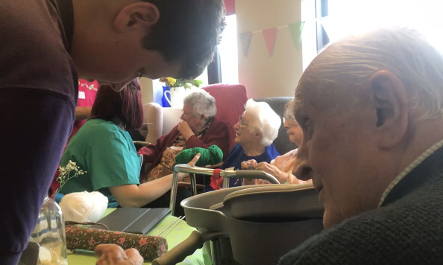
Sent later via social media:
Manager: “A very big thank you for our vintage tea party day that you organised. I think the photos say it all. The interaction between the residents and the school children was lovely to see. It was an opportunity for some of the oldest members of the local community to spend time with the newest generation within the community. The span of generations present loved exploring the reminiscence artefacts. The younger generation were introduced to items that they had not seen before such as the butter churning and also incited some of memories to the older generation
One resident who has a diagnosis of dementia is normally very unsure of anything out of her normal routines and can become anxious if out of her usual comfort zone. It was amazing to see her chatting and interacting without prompts. She was so terribly proud of her picture drawn for her by Lauren and has held her giraffe since returning. She was the last to leave the day centre which again is unusual for her as she normally likes to get back to her safe place. The experience for her has had a remarkable impact. She was laughing and smiling right up until bedtime – you really provided her with the feel good factor.”

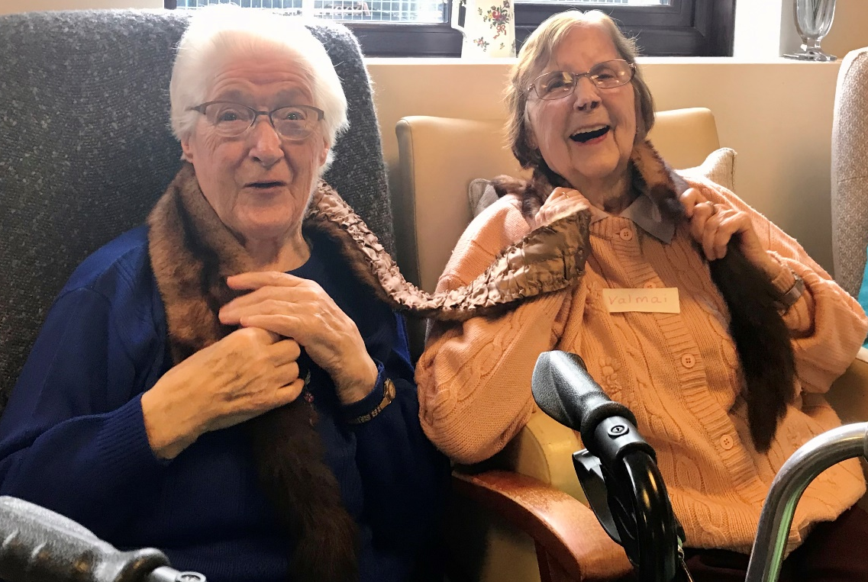

Next Time?
Lampeter Staff: want an outdoor learning space, like a roundhouse or a gazeebo but they have not got the space or money to create it. Perhaps there could be a joint fundraising project where school, residential home and community build a wheelchair accessible space in the garden of the care home for residents and pupils and community alike. Successful Futures grant? New Curriculum and creativity opportunity?
Prep the resident’s life journey, many were born here, moved away for work and moved back again. Could use People Collection Wales site from the National Library, old photographs and download onto iPad.
Post cards – old railway stations, farming communities, monuments, bridal pathways.

Appendix 4
This project has been funded through the Welsh Government Rural Communities - Rural Development Programme 2014-2020, which is funded by the Welsh Government and the European Union

